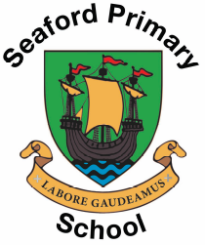
Seaford Primary School
Wilkinson Way, Seaford
East Sussex, BN25 2JF
Phone: 01323 893450
Email: office@seafordprimary.e-sussex.sch.uk
Website: seafordprimary.e-sussex.sch.uk
YouTube: @seafordprimaryschooleastsussex

Advert – Higher Level Teaching Assistant (HTLA)

The Post is for 10 hours per week on a Term Time Only, fixed Term Contract until 22-07-27. The position will be paid on Single Status grade 8 point 20-22 (Full time equivalent to £30,084-£32,067 +3% pay rise)

The successful candidate will be employed for 10 hours per week on Tuesday and Wednesday afternoons and all day on Thursdays.

Are you passionate about supporting children’s learning and helping them achieve their full potential? Seaford Primary School is seeking a skilled and enthusiastic Higher Level Teaching Assistant (HLTA) to join our dedicated team.

We are looking for someone who:
- Holds (or is working towards) HLTA status
- Has experience in a primary school or similar setting
- Demonstrates excellent communication and organisational skills
- Is committed to ensuring every child succeeds
Seaford Primary School is a great place to work with well-behaved children who are eager to learn. We are a friendly and supportive staff team and can offer a strong programme of professional development.

Information and application forms are available from our school website:

Closing date: 12 noon Monday 2nd November

Shortlisting: 2nd November

Interviews: Wednesday 4th November

The successful applicant will need to undertake an Enhanced Disclosure via the Disclosure and Barring Service (DBS) and references will be checked prior to interview. This school is committed to safeguarding and promoting the welfare of children and young people and expects all staff to share this commitment.

